**Programs on Nested Loop:**

1)Write a program to print this

*

**

***

****

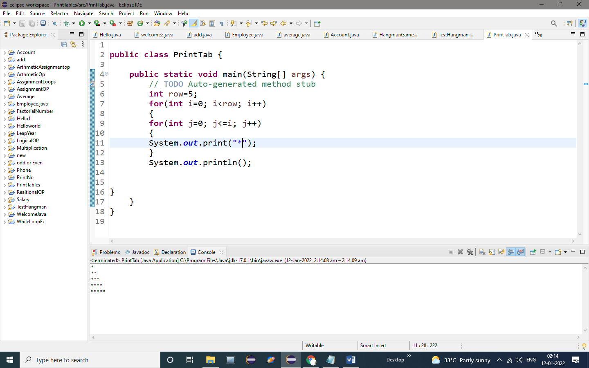

**OUTPUT:**

*

**

***

****

2. **package** loopspackage;

**public** **class** Pyramid {

**public** **static** **void** main(String[] args) {

// **TODO** Auto-generated method stub

**int** x=1;

**for**(**int** i=0;i<5;i++)

{

**for**(**int** j=0;j<5-i;j++)

System.***out***.print(" ");//printing space

**for**(**int** k=0;k<x;k++)//printing Star

{

System.***out***.print("*");

}

x=x+2;

System.***out***.println();

}

}

}

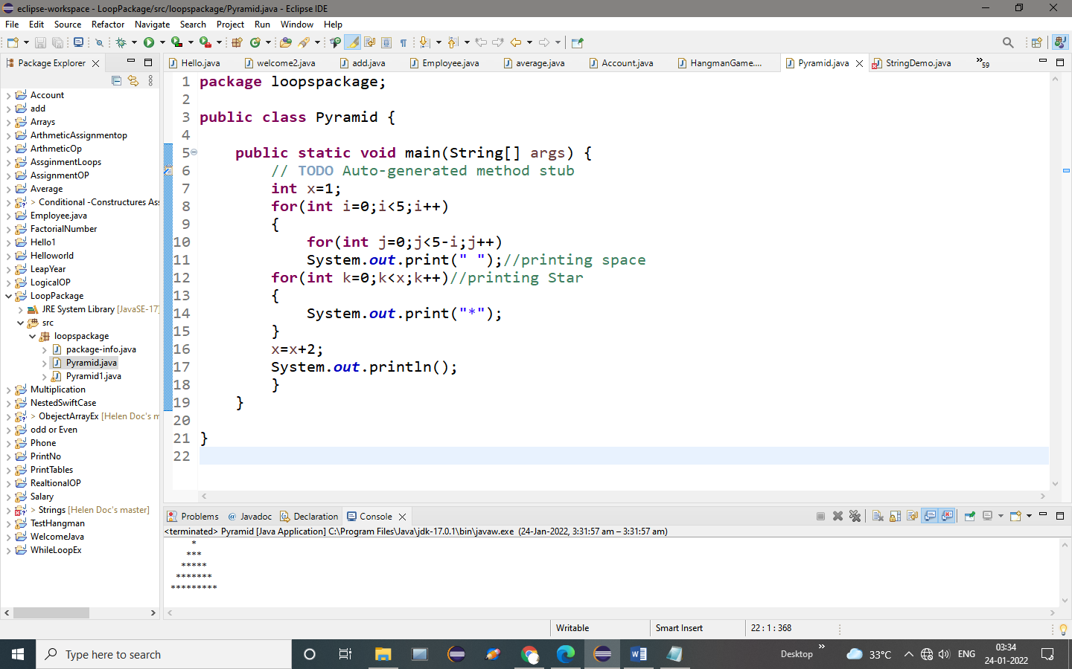

**OUTPUT:**

*

***

*****

*******

*********

**3. package** loopspackage;

**public** **class** loopPyramid {

**public** **static** **void** main(String[] args) {

// **TODO** Auto-generated method stub

**for**(**int** k=1;k<=4;k++)

{

**for**(**int** i=1;i<=10;i++)

{

System.***out***.print("*");

}

System.***out***.println();

}

}

}

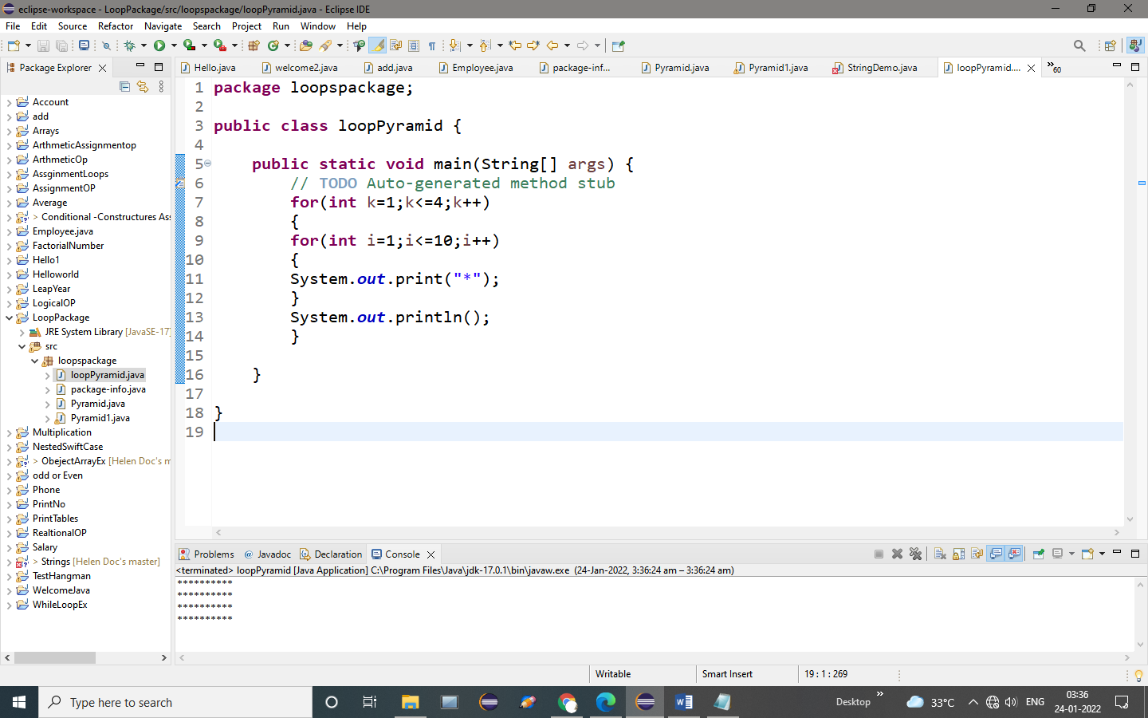

**OUTPUT:**

**********

**********

**********

**********

**4. package** loopspackage;

**public** **class** ReversePyramid {

**public** **static** **void** main(String[] args) {

// **TODO** Auto-generated method stub

**int** i, j;

**int** n = 5;

**for**(i=0; i<n; i++)

{

**for**(j=2*(n-i); j>=0; j--)

{

System.***out***.print(" ");

}

**for**(j=0; j<=i; j++)

{

System.***out***.print("* ");

}

System.***out***.println();

}

}

}

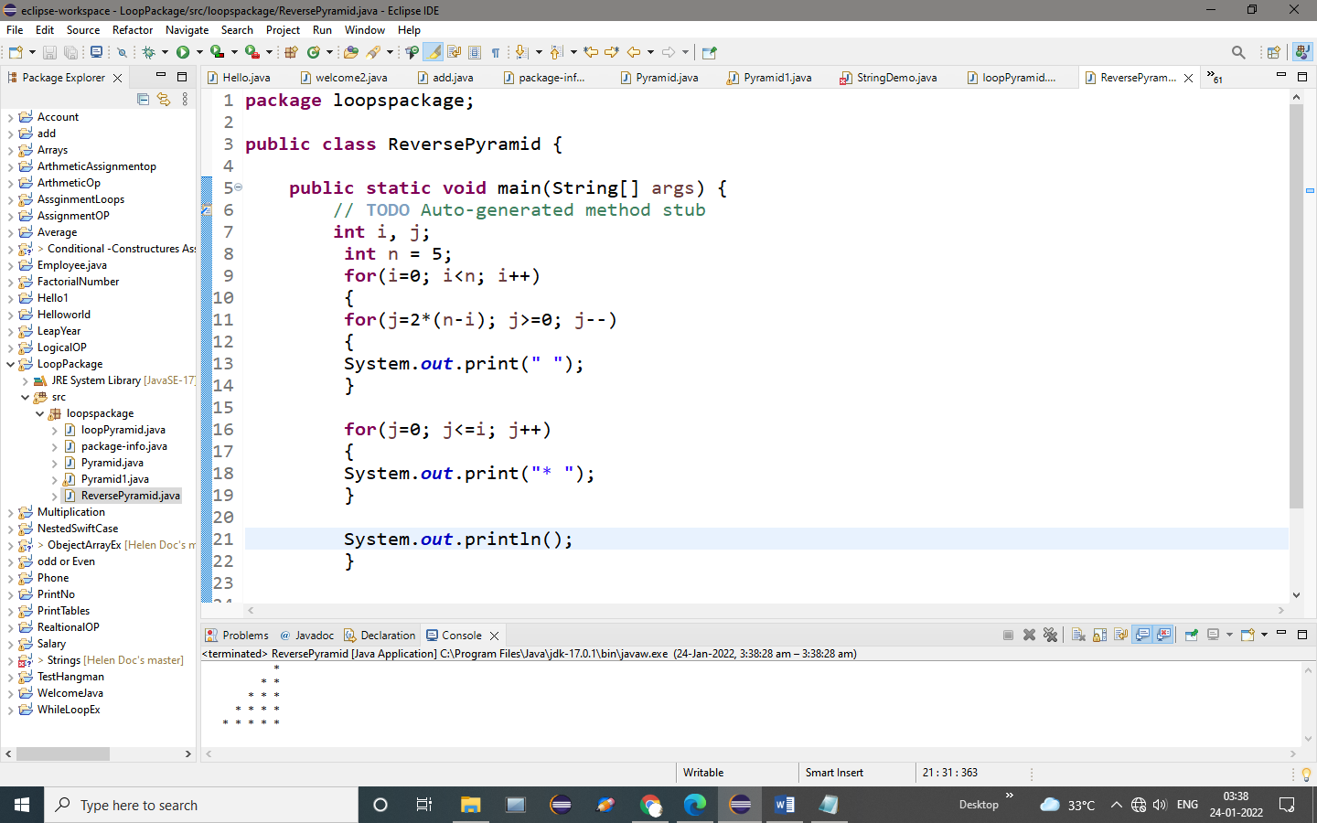

**OUTPUT:**

*

* *

* * *

* * * *

* * * * *